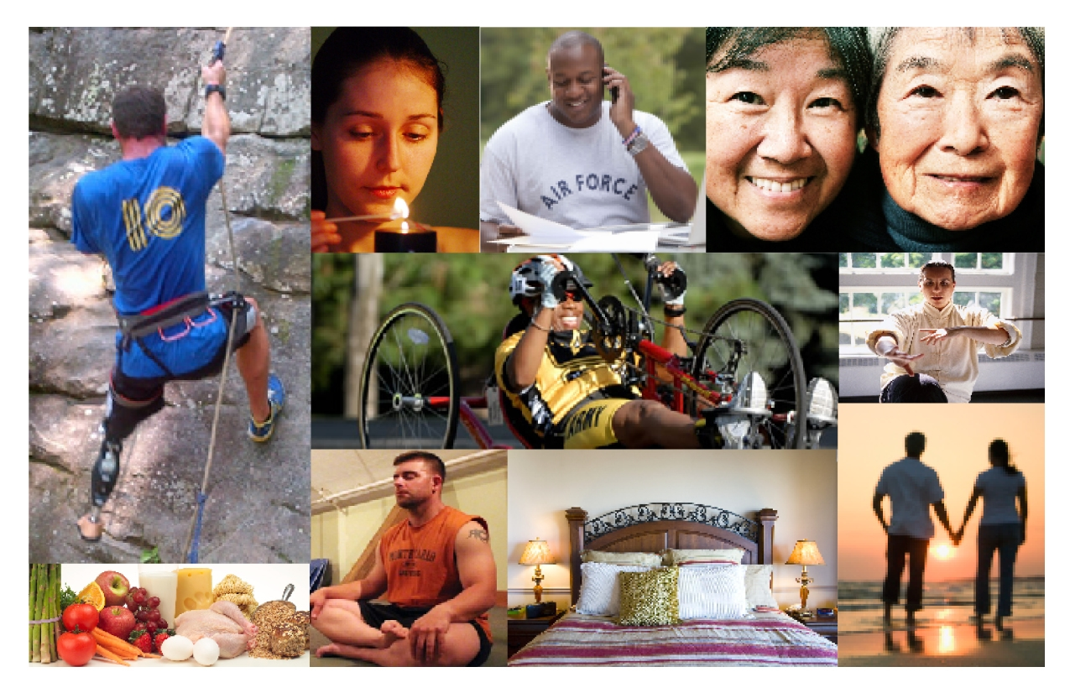

Revision XIX Sept 18, 2012
Office of Patient Centered Care and Cultural Transformation
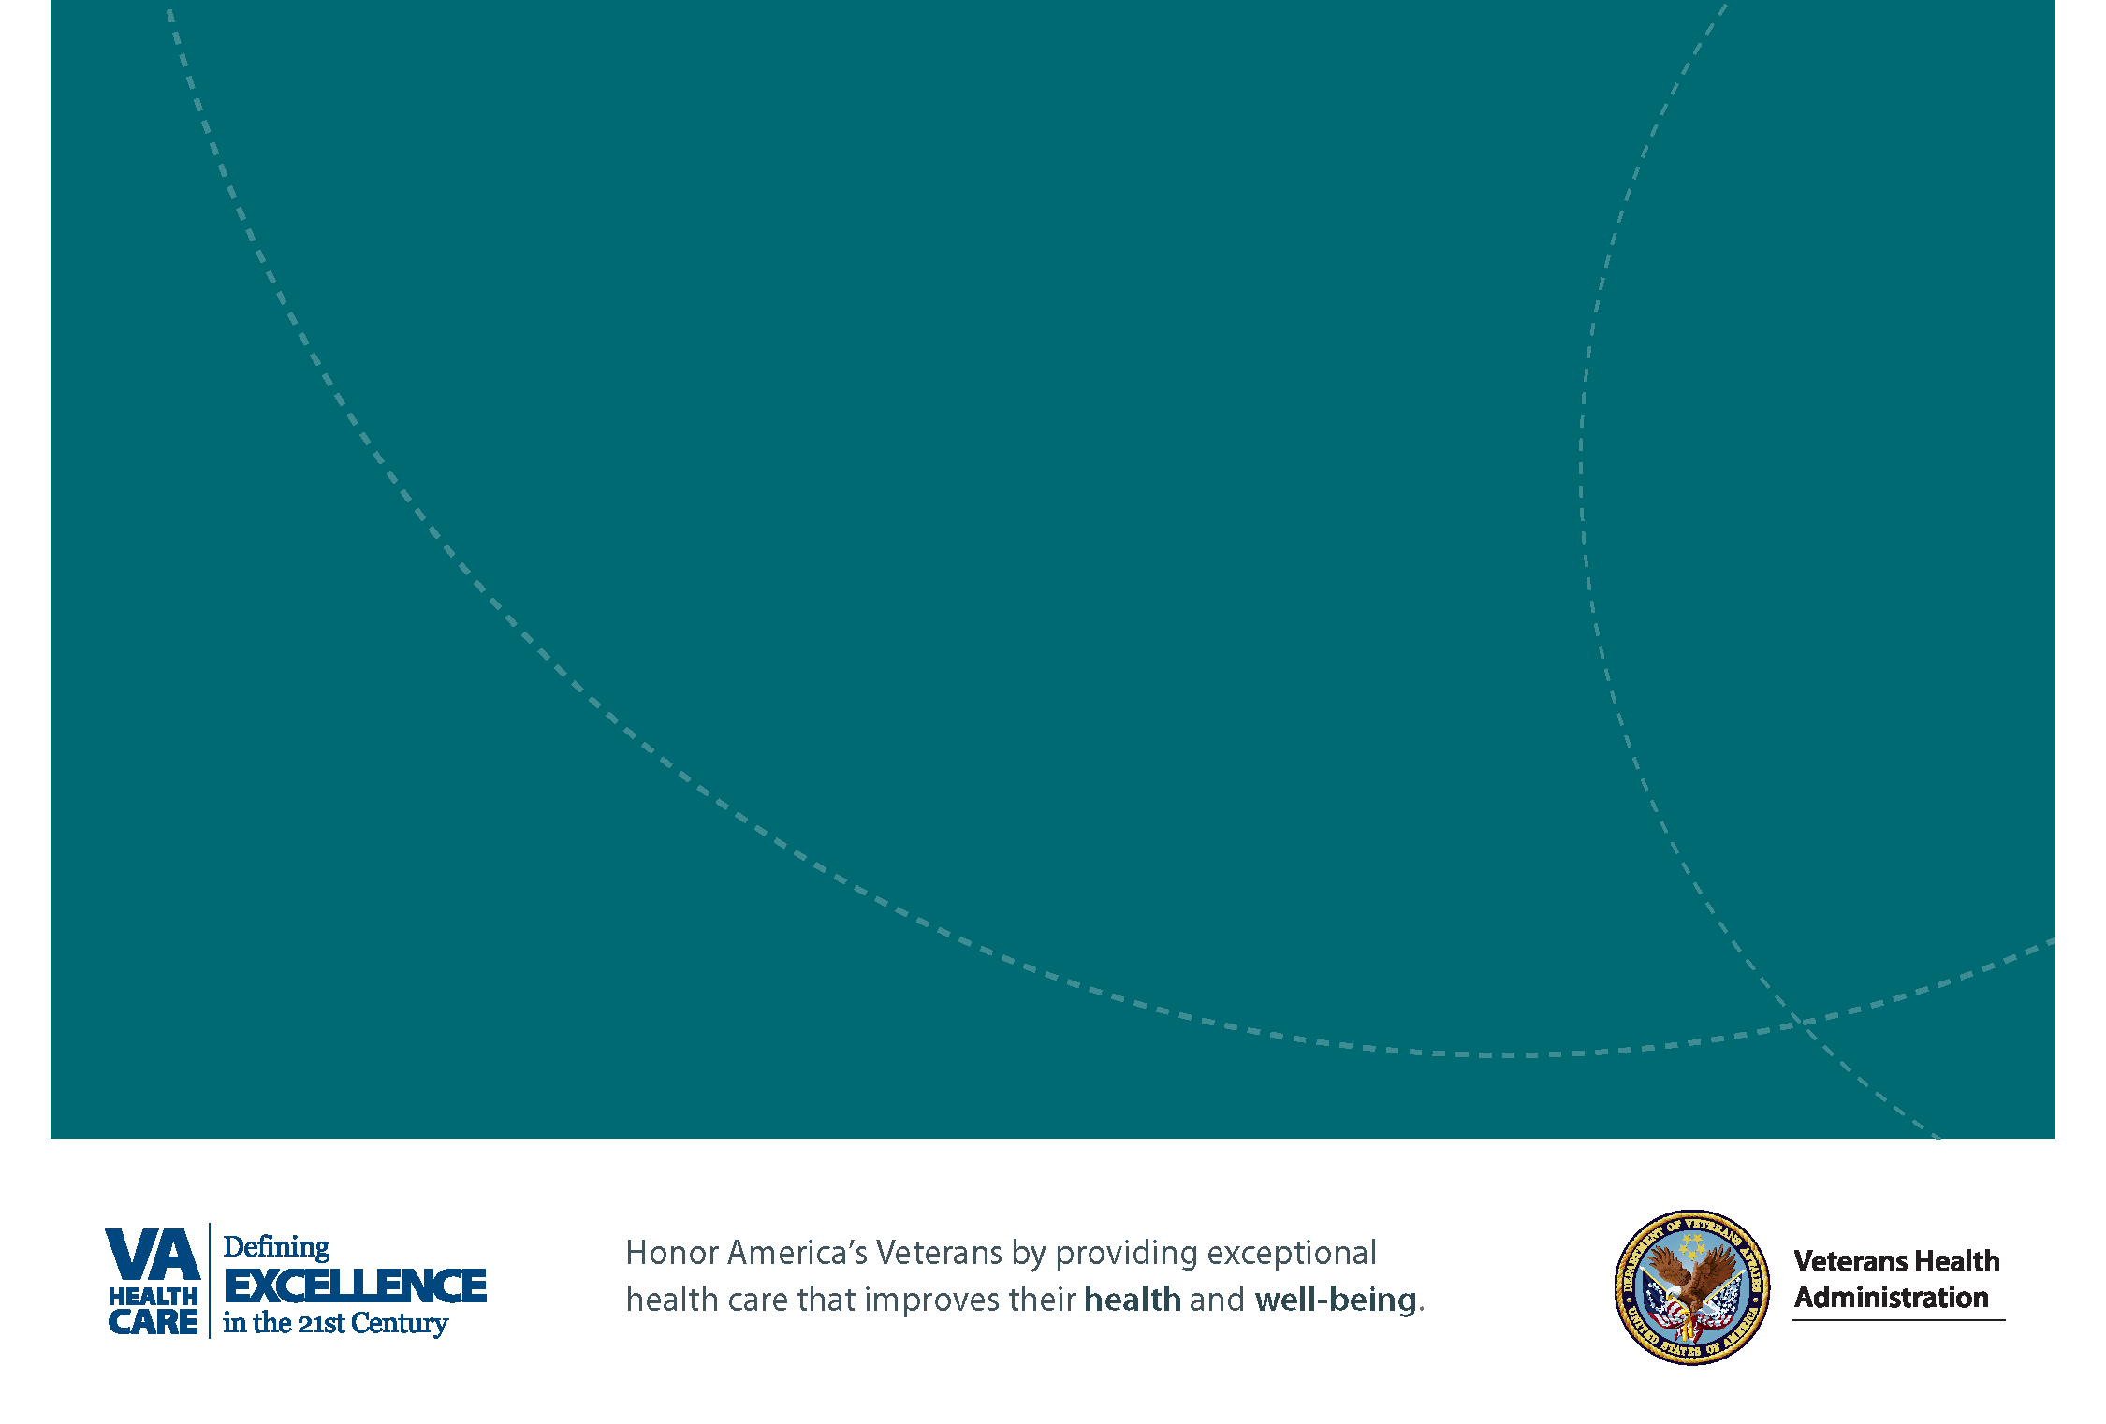
Personal Health Inventory

Personal Health Inventory

Developed by the Office of Patient Centered Care and Cultural Transformation
Revision 19, Sept 18, 2012
This document is currently being piloted and is subject to revision.
The Department of Veterans Affairs established the Office of Patient-Centered Care and Cultural Transformation (PCCCT) in January, 2011. PCCCT works with VA leadership and other program offices to transform the current system of healthcare from the traditional medical model of “find it, fix it” to a model that partners with Veterans to create a strategy to optimize health and well-being. This approach is personalized, proactive, and patient-driven and honors what really matters to people.

“You ought not to attempt to cure the eyes without the head or the head without the body, so neither ought you attempt to cure the body without the soul….for the part can never be well unless the whole is well.”
Plato

VHA and the Office of Patient Centered Care and Cultural Transformation in deeply grateful to Duke Integrative Medicine for allowing us to adapt some of the content in this handout from the “Personalized Health Plan Manual”, © 2010 Duke Integrative Medicine/Duke University Medical Center.

Health and You as a Whole Person
The road to better health rests within you. The first step is to know what you want from your health and why. Knowing your health goals may not be a simple task; yet it is an important step toward reaching your full potential. Living life fully and optimizing health and well-being goes beyond just not being sick; it means understanding what matters to you and looking at all aspects in life that contribute to a sense of well-being. This tool will help you explore all areas of your life so your health care team can help you plan, not just for your medical needs, but for your “life” needs.

The Components of Proactive Health and Well-Being
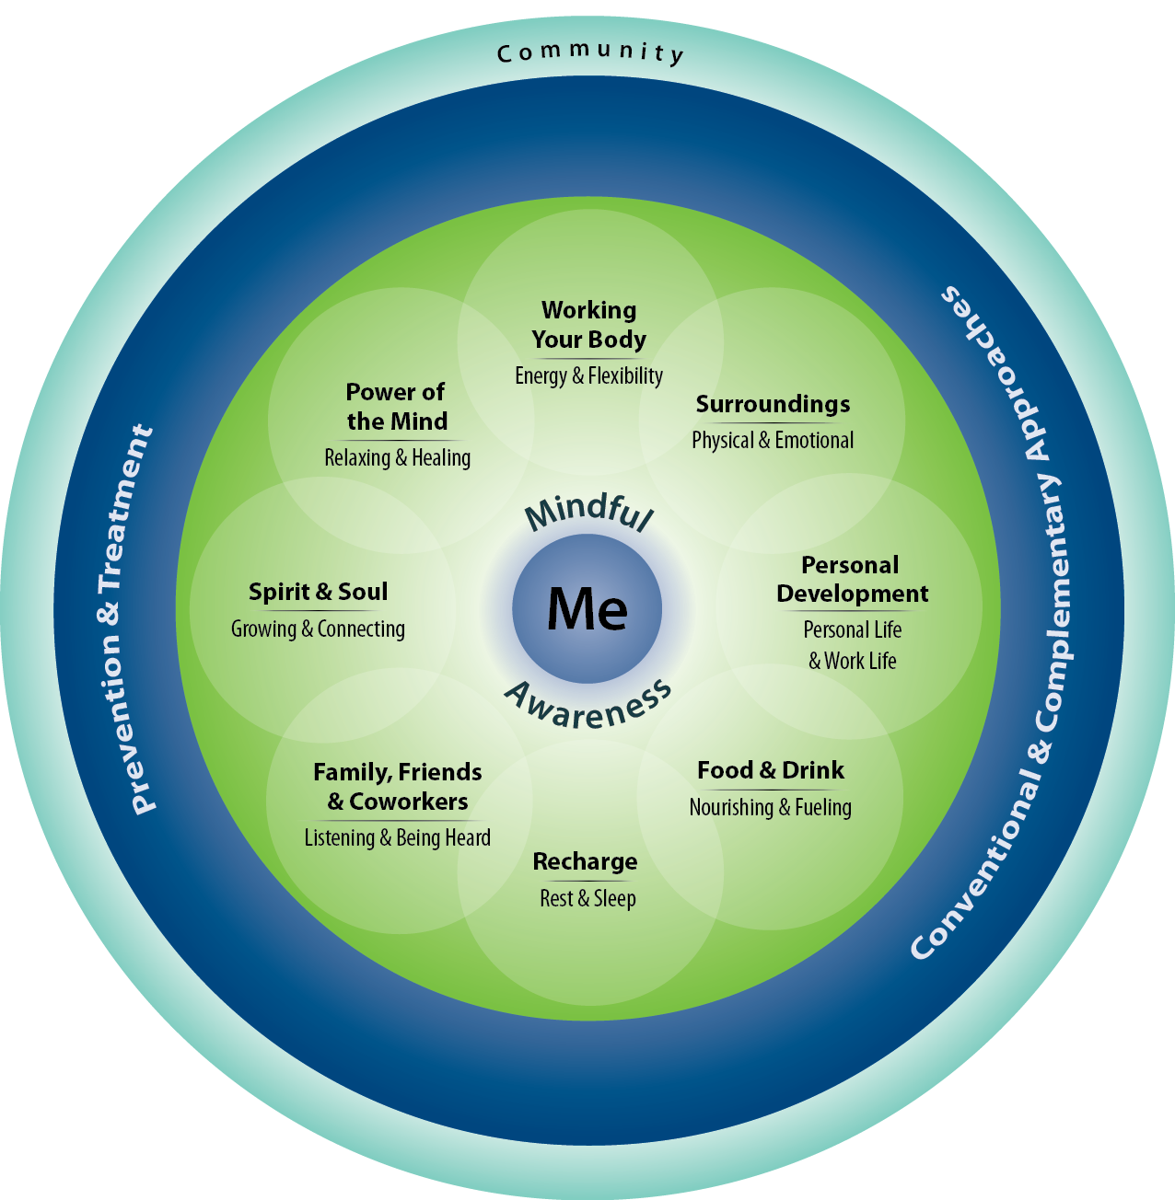

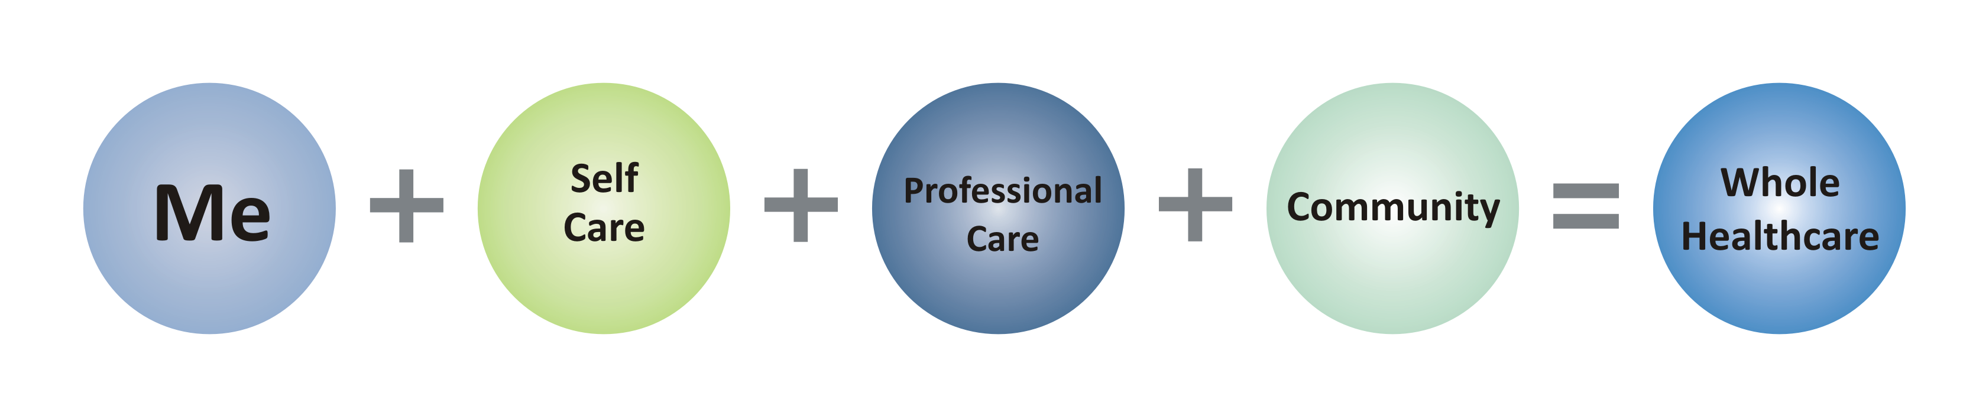
The Components of Proactive Health and Well-Being diagram is a picture to help you think about your whole health. All of the areas in the circle are important and connected. Improving one area can benefit other areas in your life and influence your overall physical, emotional, and mental health and well-being. The human body and mind have tremendous capacity to heal, and these innate healing abilities are strengthened or weakened by many factors that we can influence. The inner circle represents you, your values and what really matters to you. The next circle is your self-care, the circumstances and choices you make in your day-to-day life. The professional care ring represents professional care you receive, such as examinations, tests, medications, surgery, and counseling and complementary approaches such as acupuncture and mind-body therapies. The outer ring represents your community and the people and groups to whom you are connected.
Me
The innermost circle represents each of us and who we are as unique individuals. We start at the middle saying, “I am the expert on my life, values, goals, and priorities. Only I can know WHY I want my health. Only I can know what really matters to ME. And this knowledge needs to be what drives my health and my healthcare. I am the most important person, the Captain of the Team, when it comes to making choices that influence my health and well-being. I am the captain of my team, and my medical team professionals are some of the invited players.”
Mindful Awareness
Mindfulness is simply being fully aware, or paying attention. Sometimes, we go through our daily lives on auto-pilot and aren’t fully present in the here and now. We often dwell on the past and plan out events in the future. We don’t spend much time really noticing what is happening right now; just paying attention and noticing, without judging or trying to fix it. Your body and mind send you signals constantly, but if your attention is elsewhere, you don’t notice. Then, the signals that began as whispers become screams.
For example, when you miss the whispers of an early discomfort or a sad feeling, you miss the opportunity to make a change before it grows into real pain or depression. Being mindful, or aware, allows you to make conscious proactive choices about every aspect of your health. Mindfulness connects you to each component of your well-being, and to your whole self.

The Eight Areas of Self Care
Self-care is often the most important factor in living a healthy life, which in turn allows you to live your life fully, in the ways that matter to you. Self-care includes all the choices you make on a daily basis that affect your physical, mental, and spiritual health. As a matter of fact, how you take care of yourself will have a greater impact on your health and well-being than the medical care you receive. Evidence shows that each of these eight areas of self-care contribute a great deal to your overall health and well-being. They can also impact your chances for developing diseases as well as the course and seriousness of that disease. Consider your values, lifestyle, habits, and motivations in each area. Taking stock of where you are now (your current state) and where you want to be (your desired state) in each of these areas is the first step in living a healthier life.
Working Your Body “Energy and Flexibility”
Movement and exercise increase your energy and flexibility, and affect the state of your body and your mind and emotions. Studies show that regular exercise reduces risk factors by lowering blood pressure and cholesterol, two major contributors to the number one killer, heart disease. Physical activities of all kinds are beneficial and increase strength, flexibility, endurance, and balance. Finding what you enjoy and what works for you is important and may include activities like walking, dancing, gardening, swimming, bicycling, lifting weights, or working out in a gym.
Surroundings “Physical and Emotional”
The environment where you spend time a lot of time (like at home or work), both inside and outdoors, directly affects you and your health. You may have issues with basic needs such as safety, or things like clutter, noise, smells, chemicals, or poor lighting or water quality that keep you from being your best. Some of these factors you may be able to impact or change and some you may not. It all begins with paying attention to the influences of your environment on your life and health, and improving what you can. It matters to have safe, comfortable, and healthy spaces.
Personal Development “Personal Life and Work Life”
No matter what stage you are at in life, addressing your personal and/or work life is hugely important. This means taking a look at how you spend your time and energy throughout the day, and whether those activities fuel you or drain you. Does the balance of where and how you spend your energy line up with what matters to you? How do you feel about your finances and how are they impacting your life? These factors affect not only your happiness, but also your health.

Food and Drink “Nourishing and Fueling”
What you eat and drink can nourish and strengthen your body and mind. Your decisions about what you eat and drink impact your mood, energy level, and physical health and performance. Developing healthy drinking and eating habits that fit your lifestyle, taking supplements that support your health goals, and limiting substances like alcohol, caffeine, and nicotine keep your body properly fueled.
Recharge “Rest and Sleep”
Rest, relaxation, and sleep recharge and refuel you. Sleep is critical for important body and mind functions. Rest, relaxation, and leisure activities create a sense of peace and calm and lower stress. You may also find that physical activity, spending time with family and friends, spending time in nature, completing a significant challenge, or working on a hobby helps you to recharge. Paying attention to the balance between activity and rest is important for optimal health.

Family, Friends, and Co-Workers “Hearing and Being Heard”
Your social relationships and whether you feel isolated or connected to others are associated with whether or not you get sick, stay sick, and even how likely you are to die prematurely. In good times and challenging times, it helps to have caring and supportive relationships with people with whom you can talk to openly, knowing that they really listen to you. Intimate relationships and sexual health are not always topics people feel comfortable talking about. The negative effects of sexual trauma or feelings of inadequacies can be devastating. Positive and healthy intimate relationships can be a source of strength.
Spirit and Soul “Growing and Connecting”
A sense of meaning and purpose in life and a connection to things outside of you are words that describe the core of what is really important to many people. Where do you turn for a sense of strength and comfort in difficult times? Some people turn to faith, religious practice, or time in nature. Some connect with art or music or prefer quiet time alone. You may express this as a guiding principle for living and giving, a regard for others, or a connection with your inner self in ways that fuel you.
Power of the Mind “Strengthen and Listen”
The mind directly impacts the state of your body, in both positive and negative ways. Think of a lemon and you salivate. Think of something that stresses you and your heart rate and blood pressure jump. Learning to use this connection intentionally for positive effects is easy to do. Mind-body practices strengthen the communication between your body, brain, and mind. Think about highly trained athletes or warriors who use the power of their mind to visualize success, or people who use the power of their mind to lower their blood pressure or control pain. You can learn to optimize your body’s ability to heal and cope better with mental and physical stress, by using mind-body techniques.

Professional Care
The professional care ring represents your relationship with your healthcare team or others who are a part of your team. This includes preventive care (like immunizations, weight control, and not smoking), and early detection of disease (such as blood pressure readings and cancer screenings like PAP smears and colonoscopies). It also includes being evaluated for signs or symptoms of problems, and often involves testing and diagnostics, followed by interventions or treatments for the full range of conditions or diseases. Drawing on the best and most effective treatments or approaches is critical, and includes traditional or conventional services (such as medications, counseling, and surgery), as well as complementary approaches (like acupuncture, supplements, and mind body therapies). The plan to manage or treat disease, as well as to prevent disease, will all include strategies that are rooted in your self-care.
Community
The outer ring represents your community and the people, customs, cultures, groups, organizations, causes, governments, and locations you are connected to. For some people, their community is near-by and local and for others it includes people and things that are far away and far-reaching. Today, with the internet, Skype, and Facebook, people can have connections all around the world. Your community is more than the places where you live, work, and worship, it includes the people and groups you are connected to; upon whom you rely and who rely on you.

Discovering Why You Want Your Health and Developing Your Personal Health Goals
You are the expert on you! The first and most important step in creating your roadmap to your healthiest life is to step back from your health concerns, and think about your life. What really matters to you? Why do you want or need your health? Sometimes, it can be hard to figure this out. This workbook will help you think about where you are now and where you want to be. Take a few minutes to relax and really think broadly and openly as you answer the questions. You may use additional paper to answer the questions, if you need to.

Your Personal Health Inventory
- What REALLY matters to you in your life?

- What brings you a sense of joy and happiness?

- What brings you a sense of sadness or sorrow?

- What is your vision of your best possible health?
How would you like to feel and look? What activities would you like to be able to do?

5. On the following scales, place an “X” showing where you feel you are on the scale.

Physical Scale:
0 10
Miserable Great
(pain, weak, drained) (high-energy, strong, fit)
Mental/Emotional Scale:
0 10

Miserable Great
(anxious, angry, hopeless, alone) (happy, hopeful, connected, content)

Life Scale: How is it to live your day to day life?
0 10

Miserable Great
(very hard, exhausting) (easy, fulfilling)

Current and Desired States
For each area below, consider where you are now and where you would like to be. In the “current state” box, briefly note the reasons you chose your number. In the “desired state” box, write down some changes that might make this area stronger for you.

Working the Body: “Energy and Flexibility” Movement and physical activities like walking, dancing, gardening, sports, lifting weights, yoga, cycling, swimming, and working out in a gym.
Current State: Rate yourself on a scale of 1 (low) to 10 (high)  1 2 3 4 5 6 7 8 9 10 | Desired State: Where would you like to be?  1 2 3 4 5 6 7 8 9 10
What are the reasons you choose this number? | What changes could you make to help you get there?
Recharge: “Rest and Sleep” Getting enough rest and sleep and participating in activities that help you feel recharged and fueled.
Current State: Rate yourself on a scale of 1 (low) to 10 (high)  1 2 3 4 5 6 7 8 9 10 | Desired State: Where would you like to be?  1 2 3 4 5 6 7 8 9 10
What are the reasons you choose this number? | What changes could you make to help you get there?
Food and Drink: “Nourish and Fuel” Eating healthy well-balanced meals with plenty of fruits and vegetables each day. Drinking enough water and limiting sodas, sweetened drinks, and alcohol.
Current State: Rate yourself on a scale of 1 (low) to 10 (high)  1 2 3 4 5 6 7 8 9 10 | Desired State: Where would you like to be?  1 2 3 4 5 6 7 8 9 10
What are the reasons you choose this number? | What changes could you make to help you get there?

Personal Development: “Personal life and Work life” Learning and growing. Developing abilities and talents. Balancing responsibilities where you live, volunteer, and work.
Current State: Rate yourself on a scale of 1 (low) to 10 (high)  1 2 3 4 5 6 7 8 9 10 | Desired State: Where would you like to be?  1 2 3 4 5 6 7 8 9 10
What are the reasons you choose this number? | What changes could you make to help you get there?
Family, Friends, and Co-Workers: “Hearing and Being Heard” Having caring and supporting relationships where you feel heard and connected to the people you love and care about. The quality of your communication with family, friends and your co-workers.
Current State: Rate yourself on a scale of 1 (low) to 10 (high)  1 2 3 4 5 6 7 8 9 10 | Desired State: Where would you like to be?  1 2 3 4 5 6 7 8 9 10
What are the reasons you choose this number? | What changes could you make to help you get there?
Spirit and Soul: “Growing and Connecting” Having a sense of purpose and meaning in your life. Feeling connecting to something larger than yourself. Finding strength in difficult times. This may include your faith or religion, meaningful community organizations, or other sources of comfort and strength like music, nature, or the arts.
Current State: Rate yourself on a scale of 1 (low) to 10 (high)  1 2 3 4 5 6 7 8 9 10 | Desired State: Where would you like to be?  1 2 3 4 5 6 7 8 9 10
What are the reasons you choose this number? | What changes could you make to help you get there?

Surroundings: “Physical and Emotional” Feeling safe and having comfortable, healthy spaces where you work and live. The quality of the lighting, color, air, and water. Decreasing unpleasant clutter, noises, and smells.
Current State: Rate yourself on a scale of 1 (low) to 10 (high)  1 2 3 4 5 6 7 8 9 10 | Desired State: Where would you like to be?  1 2 3 4 5 6 7 8 9 10
What are the reasons you choose this number? | What changes could you make to help you get there?
Power of the Mind: “Strengthen and Listen” Tapping into the power of your mind to heal and cope. Listening to your inner thoughts, paying attention, and noticing. Using mind-body techniques like relaxation, breathing, biofeedback, or guided imagery.
Current State: Rate yourself on a scale of 1 (low) to 10 (high)  1 2 3 4 5 6 7 8 9 10 | Desired State: Where would you like to be?  1 2 3 4 5 6 7 8 9 10
What are the reasons you choose this number? | What changes could you make to help you get there?
Professional Care, Prevention: Being up to date on vaccines (e.g. flu, pneumonia, and shingles shots). Getting recommended cancer screenings (PAP smear, colonoscopy, mammogram) and blood tests (cholesterol). Not smoking and avoiding second hand smoke. Wearing seat belts. Limiting alcohol use. Use of nutritional supplements and complementary therapies.
Prevention Current State: Rate yourself on a scale of 1 (low) to 10 (high)  1 2 3 4 5 6 7 8 9 10 | Prevention: Desired State: Where would you like to be?  1 2 3 4 5 6 7 8 9 10
What are the reasons you choose this number? | What changes could you make to help you get there?

Professional Care, Intervention: If you are under the care of a healthcare professional, understanding your treatment plan and how to take your medications. Asking questions when you don’t understand your treatment plan or the plan doesn’t fit with what matters to you. Use of vitamins and supplements. Use of complementary therapies
Interventions: Current State: Rate yourself on a scale of 1 (low) to 10 (high)  1 2 3 4 5 6 7 8 9 10 | Interventions: Desired State: Where would you like to be?  1 2 3 4 5 6 7 8 9 10
What are the reasons you choose this number? | What changes could you make to help you get there?

Reflections
- What stands out for you about where you currently are and where you‘d like to be?

- If nothing changes in your health and well-being choices, what do you think your health will look like 5 years from now? What might the worst case be?

- If you make changes in your health habits, what is your likely health 5 years from now? What might the best case scenario be?

