Welcome to the VA Mobile Health Family Caregiver Pilot,
Developed by the US Department of Veterans Affairs!

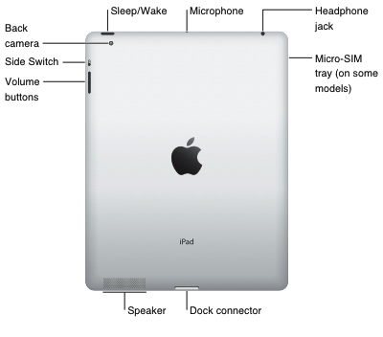
My iPad2 is out of the box, now what?
If you do not have a computer, you can start using your VA-issued iPad by plugging it into a wall outlet using the power adapter and dock connector included in the box (refer to the diagram to the right). Once plugged in, hold the black switch on the upper corner of the iPad (sleep/wake button). Once charged and turned on, Apple will walk you through a series of simple steps. If you do not have an Apple ID, please obtain one when prompted. When asked for a credit card number, you can skip that step OR enter your own personal number if you plan to purchase any personal Apps. ALL VA Mobile Apps are free.

If you have a computer with iTunes and you want to connect it with this iPad, start by connecting the iPad to your computer with the iPad USB/dock connection cable. Once connected, iTunes will open automatically. In a matter of seconds, the iPad will sync to the iTunes program. iTunes will walk you through the iPad set-up, introduce you to your tablet and help you register your device. If you don’t have iTunes installed on your computer and you want to sync the iPad on your personal computer, you can download it from www.itunes.com. For detailed information about syncing iPad with iTunes on your computer, open iTunes then select iTunes “Help” from the Help menu.

Handling the iPad with Care - Please remember, this iPad was issued to you by the government, and it is your responsibility to protect it. We have provided a case that will assist in keeping it free from scratches and protecting from damage.

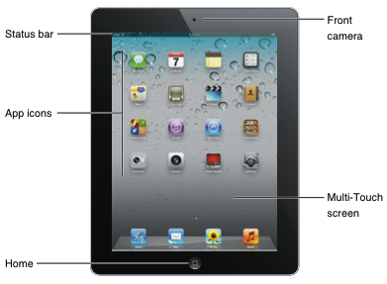
Navigating - When your iPad is first turned on it will look similar to the image on the left. Take a few moments to get familiar with the buttons on the device. The home button on the front of your iPad, when pressed, will always return you to the home screen on your iPad.

iPad2 Settings - Wi-Fi settings determine whether iPad uses local Wi-Fi networks to connect to the Internet. When iPad is joined to a Wi-Fi network, the Wi-Fi icon in the status bar at the top of the screen shows signal strength. The more bars you see, the stronger the signal. To join a Wi-Fi connection, select the settings App on your home screen (grey gear icon), tap Wi-Fi and choose a network. Once you join a Wi-Fi network, iPad automatically connects to it whenever the network is in range. If more than one previous used network is in range, iPad joins the one last used. If no Wi-Fi networks are available, iPad Wi-Fi + 3G connects over the cellular network, if possible. You are limited to 2GB of data on the 3G network per month with your VA-issued iPad2. After you use those 2GB, your 3G will no longer work and you can only connect to the internet on the iPad using Wi-Fi. We recommend using Wi-Fi whenever possible to reduce the amount of data you use.

Security Features - Mobile Device Management is installed in your device giving VA the ability to wirelessly configure and update settings as well as remotely wipe or lock managed devices in the event that it is lost or stolen. For additional security, you can set up a passcode that you must enter each time you turn on or wake up iPad. To Set a passcode: Go to Settings > General > Passcode Lock > Turn Passcode On. Enter a four-digit passcode, and then enter it again to verify it.

Apple App Store - The Apple App Store is home to all Apps made for iPad, to sign in, just use your Apple ID. There are many free Apps you can download without entering credit card information. If you decide to purchase apps, you must add your personal credit card number to your Apple ID. If you decide to purchase Apps, VA cannot reimburse participants for purchased Apps when the iPad2 is turned in. Those Apps will be deleted. Reminder! It is important to remember that the Apple App Store will not store any personal patient information that you enter in the VA Apps.

Department of Veterans Affairs Launch Pad - The VA Launch Pad will be pre-installed on your VA-supplied iPad. The Launch Pad will provide quick access to all VA-supported Apps you will need for this program. All patient sensitive information entered into these VA Apps is transmitted securely by VA. You may choose to use other Apps and create your own data within the iPad. Because you have control of your own data, we recommend you set up a password on your iPad in the Settings App. And remember, VA Apps available in the VA Launch Pad are always free.

Need More Help?
There are videos available that will offer quick tips and tutorials on navigating on your iPad. You can find the link to VA’s Mobile Health YouTube channel on your iPad home screen.

Check out the Apple iPad User Guide - In Safari tap then tap the “iPad User Guide” bookmark. Add an icon for the user guide to the Home screen: Tap then tap “Add to Home Screen.” You can tap “Add to Home Screen” for any of your preferred Web sites.

Having Technical Issues?
Did you accidentally delete the VA Launch Pad? Is your iPad having problems charging? Do you have some other problem or question? The VA Clinic-in-Hand Help Desk supports VA mobile applications. The help desk can be reached at 877-470-5947, Monday - Friday, 7 a.m. -7 p.m. (Central Time).

For Further Guidance
Please visit VA’s Mobile Health homepage, which will contain information on the VA Mobile Health Family Caregiver Pilot as well as information on other mobile initiatives, links to more iPad help, links to training, news and announcements. The Web site is available on your iPad or desktop athttp://mobileheath.va.gov

